**EXPERIMENT – 9(A)**

**AIM (9A):** IMPLEMENTATION OF CODE OPTIMIZATION TECHNIQUES any three (preferable Common sub expression elimination, constant folding, variable propagation)

**THEORY:**

**-** Introduction to code optimization

**Ans:** The code optimization in the synthesis phase is a program transformation technique, which tries to improve the intermediate code by making it consume fewer resources (i.e. CPU, Memory) so that faster-running machine code will result.

Compiler optimizing process should meet the following objectives:

* The optimization must be correct, it must not, in any way, change the meaning of the program.
* Optimization should increase the speed and performance of the program.
* The compilation time must be kept reasonable.

The optimization process should not delay the overall compiling process.

**-** Type of Code optimization techniques

**Ans:** Common SubExpression Elimination -

The expression that has been already computed before and appears again in the code for computation is called Common SubExpression Elimination.

In this technique,

* As the name suggests, it involves eliminating the common sub expressions.
* The redundant expressions are eliminated to avoid their re-computation.
* The already computed result is used in the further program when required.

|  |  |
| --- | --- |
| Code Before Optimization | Code After Optimization |
| S1 = 4 x i  S2 = a[S1]  S3 = 4 x j  S4 = 4 x i // Redundant Expression  S5 = n  S6 = b[S4] + S5 | S1 = 4 x i  S2 = a[S1]  S3 = 4 x j  S5 = n  S6 = b[S1] + S5 |

Constant Folding -

In this technique,

* As the name suggests, it involves folding the constants.
* The expressions that contain the operands having constant values at compile time are evaluated.
* Those expressions are then replaced with their respective results.

Example-

Circumference of Circle = (22/7) x Diameter

Here,

* This technique evaluates the expression 22/7 at compile time.
* The expression is then replaced with its result 3.14.
* This saves time at run time.

Variable Propagation -

In this technique,

* If some variable has been assigned some constant value, then it replaces that variable with its constant value in the further program during compilation.
* The condition is that the value of the variable must not get altered in between.

Example-

pi = 3.14

radius = 10

Area of circle = pi x radius x radius

Here,

* + - This technique substitutes the value of variables ‘pi’ and ‘radius’ at compile time.
    - It then evaluates the expression 3.14 x 10 x 10.
    - The expression is then replaced with its result 314.
    - This saves time at run time.

**-** Working Example

**Ans:**

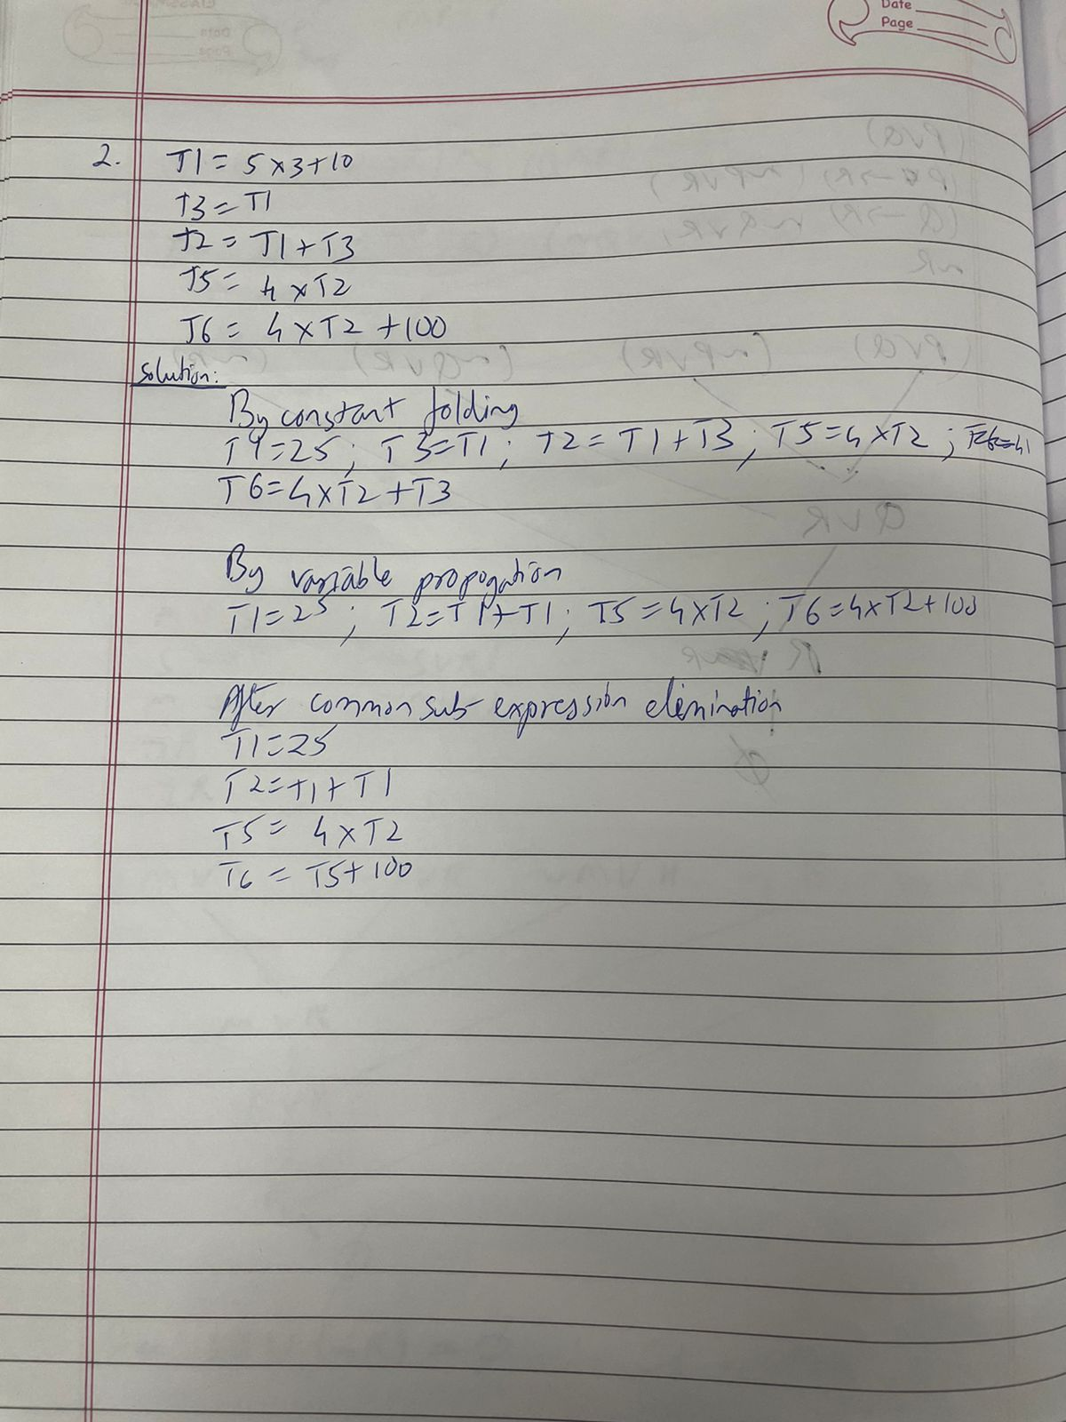

**IMPLEMENTATION:**

**-** Pseudo code (handwritten Algorithm)

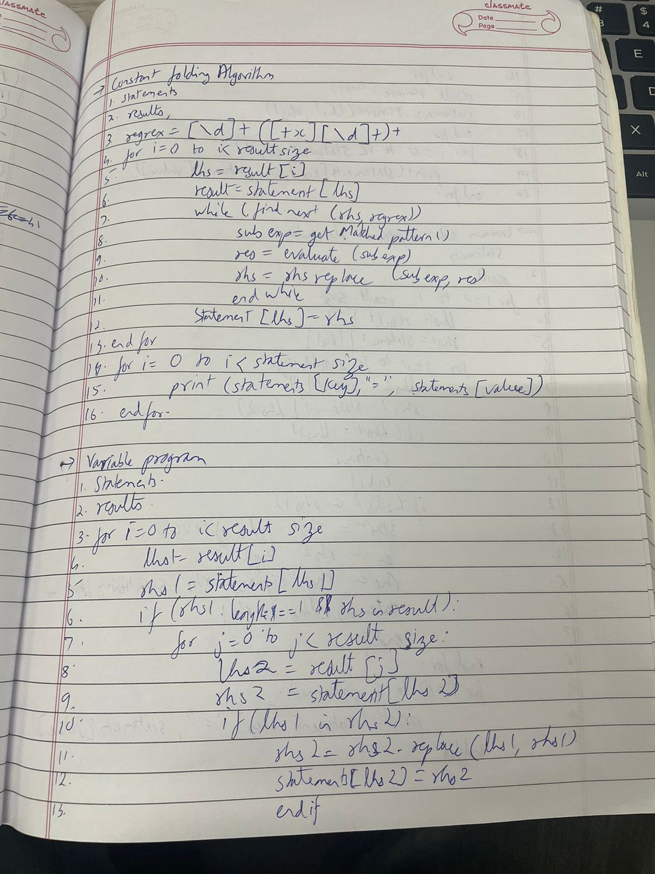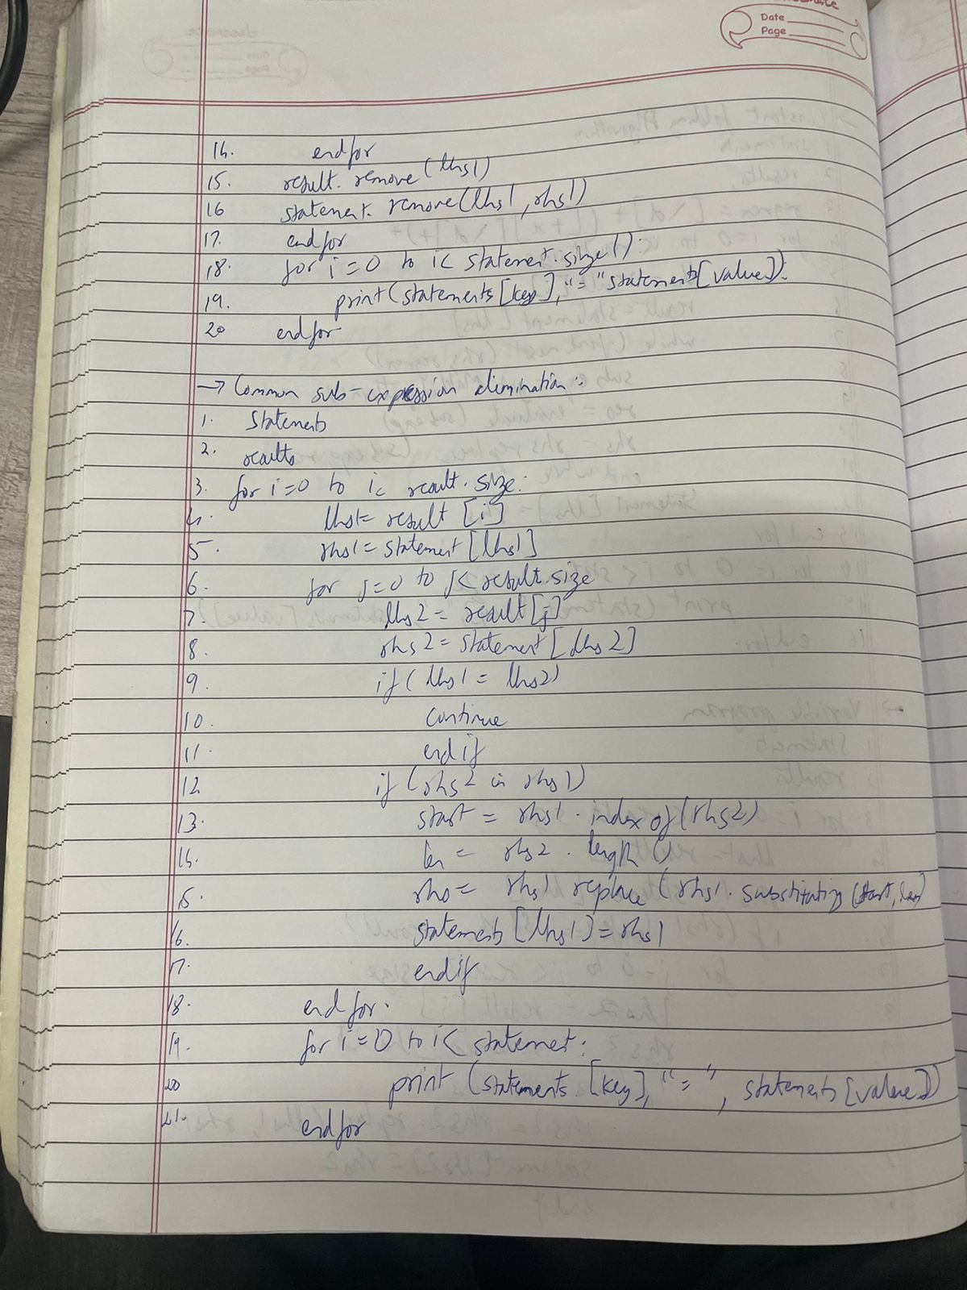

**-** CODE (C / Java) – printed code

import java.util.*;

import java.util.regex.Matcher;

import java.util.regex.Pattern;

public class CodeOptimize

{

    HashMap < String, String > statements = new HashMap <> ();

    List < String > result = new ArrayList < String > (Arrays.asList ("a", "b", "c", "d", "e"));

    List < String > operators =

        new ArrayList < String > (Arrays.asList ("+", "*"));

    public static void main (String[]args)

    {

        CodeOptimize obj = new CodeOptimize();

        obj.getStatements ();

        System.out.println ("Initaially statements are: ");

        obj.putStatements ();

        obj.constantFolding ();

        System.out.println ("After constant folding: ");

        obj.putStatements ();

        obj.variablePropagation ();

        System.out.println ("After variable propagation: ");

        obj.putStatements ();

        obj.commonSubexpElim ();

        System.out.println ("After Common Sub-expression Elimination: ");

        obj.putStatements ();

    }

    public void getStatements ()

    {

        this.statements.put ("a", "5*3+10");

        this.statements.put ("b", "a");

        this.statements.put ("c", "a+b");

        this.statements.put ("d", "4*c");

        this.statements.put ("e", "4*c+100");

    }

    public void putStatements ()

    {

        for (Map.Entry mapElement:this.statements.entrySet ())

        {

            String key = (String) mapElement.getKey ();

            String value = (String) mapElement.getValue ();

            System.out.println (key + " : " + value);

        }

        System.out.println ("----------------------------------------");

    }

    public int evaluate (String str)

    {

        String[]arr = str.split ("\\+");

        for (int i = 0; i < arr.length; i++)

        {

            int result = 1;

            if (arr[i].contains ("*"))

            {

                String[]num = arr[i].split ("\\*");

                for (int j = 0; j < num.length; j++)

                {

                    result *= Integer.parseInt (num[j]);

                }

                arr[i] = String.valueOf (result);

            }

        }

        int len = arr.length;

        int sum = 0;

        for(int i = 0; i < len; i++)

        {

            sum += Integer.parseInt (arr[i]);

        }

        return sum;

    }

    public void constantFolding ()

    {

        for (int i = 0; i < this.result.size (); i++)

        {

            String lhs = this.result.get (i);

            String rhs = this.statements.get (lhs);

            Pattern p = Pattern.compile ("[\\d]+([+*][\\d]+)+");

            Matcher m = p.matcher (rhs);

            while (m.find ())

            {

                String subexpr = m.group ();

                int result = this.evaluate (subexpr);

                String res = String.valueOf (result);

                rhs = rhs.replace (rhs.substring (m.start (), m.end ()), res);

                m = p.matcher (rhs);

            }

            this.statements.put (lhs, rhs);

        }

    }

    public void variablePropagation ()

    {

        for (int i = 0; i < this.result.size (); i++)

        {

            String lhs1 = this.result.get (i);

            String rhs1 = this.statements.get (lhs1);

            if (rhs1.length () == 1 && this.result.contains (rhs1))

            {

                for (int j = 0; j < this.result.size (); j++)

                {

                    String lhs2 = this.result.get (j);

                    String rhs2 = this.statements.get (lhs2);

                    if (rhs2.contains (lhs1))

                    {

                        rhs2 = rhs2.replace (lhs1, rhs1);

                        this.statements.put (lhs2, rhs2);

                    }

                }

                this.result.remove (lhs1);

                this.statements.remove (lhs1, rhs1);

            }

        }

    }

    public void commonSubexpElim ()

    {

        for (int i = 0; i < this.result.size (); i++)

        {

            String lhs1 = this.result.get (i);

            String rhs1 = this.statements.get (lhs1);

            for (int j = 0; j < this.result.size (); j++)

            {

                String lhs2 = this.result.get (j);

                String rhs2 = this.statements.get (lhs2);

                if (lhs1 == lhs2)

                {

                    continue;

                }

                if (rhs1.contains (rhs2))

                {

                    int start = rhs1.indexOf (rhs2);

                    int len = rhs2.length ();

                    rhs1 = rhs1.replace(rhs1.substring(start,len),lhs2);

                    this.statements.put(lhs1,rhs1);

                }

            }

        }

    }

}

**OUTPUT:**

Program and output to optimize a given code.

Input program (Three address code) to be given as a text file.

Input.txt (before optimization)

T1= 5*3+10 // Constant folding

T3=T1 //variable propagation

T2=T1+T3

T5=4*T2 // common sub-expression elimination T6=4*T2+100

Output (After Optimization)

T1=25

T2=T1+T1

T5=4*T2

T6=T5+100

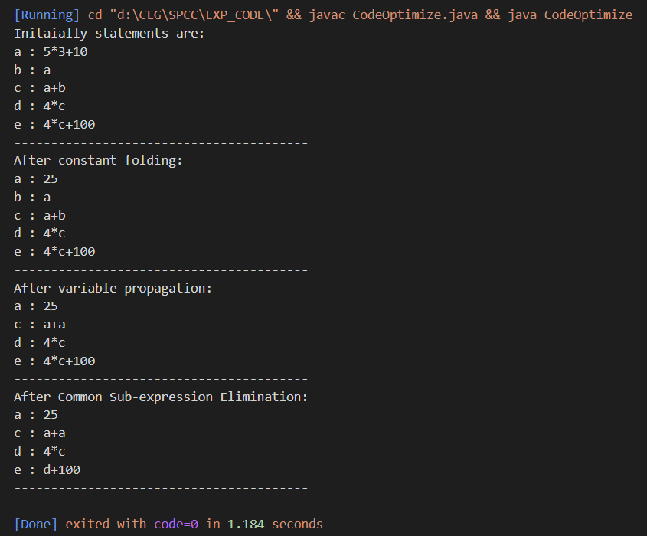

**CONCLUSION:** From the above experiment we are able to learn about various code optimization techniques like the constant folding, variable propagation and common subexpression elimination.

**Aim 9 (B):** TO IMPLEMENT INTERMEDIATE CODE GENERATION ALGORITHM.

**Theory:**

* What is the role of Code Generation in Compiler Design?

Ans: Code Generation -

Code generation can be considered as the final phase of compilation. Through post code generation, optimization processes can be applied on the code, but that can be seen as a part of the code generation phase itself. The code generated by the compiler is an object code of some lower-level programming language, for example, assembly language. We have seen that the source code written in a higher-level language is transformed into a lower-level language that results in a lower-level object code, which should have the following minimum properties:

* It should carry the exact meaning of the source code.
* It should be efficient in terms of CPU usage and memory management.

* What are the issues in design of Code generation?

Ans: The following issue arises during the code generation phase:

1. Input to code generator –  
   The input to code generator is the intermediate code generated by the front end, along with information in the symbol table that determines the run-time addresses of the data-objects denoted by the names in the intermediate representation. Intermediate codes may be represented mostly in quadruples, triples, indirect triples, Postfix notation, syntax trees, DAG’s, etc.
2. Target program –  
   The target program is the output of the code generator. The output may be absolute machine language, relocatable machine language, assembly language.
3. Memory Management –  
   Mapping the names in the source program to the addresses of data objects is done by the front end and the code generator. A name in the three address statements refers to the symbol table entry for name. Then from the symbol table entry, a relative address can be determined for the name.
4. Instruction selection –  
   Selecting the best instructions will improve the efficiency of the program. It includes the instructions that should be complete and uniform. Instruction speeds and machine idioms also play a major role when efficiency is considered.
5. Evaluation order –  
   The code generator decides the order in which the instruction will be executed. The order of computations affects the efficiency of the target code. Among many computational orders, some will require only fewer registers to hold the intermediate results. However, picking the best order in the general case is a difficult NP-complete problem.
6. Approaches to code generation issues: Code generators must always generate the correct code. It is essential because of the number of special cases that a code generator might face. Some of the design goals of code generator are:
   * Correct
   * Easily maintainable
   * Testable
   * Efficient

* Explain Code Generation Algorithm with the help of an example.

Ans: Code Generation Algorithm -

The algorithm takes a sequence of three-address statements as input. For each three address statement of the form a:= b op c perform the various actions. These are as follows:

1. Invoke a function getreg to find out the location L where the result of computation b op c should be stored.
2. Consult the address description for y to determine y'. If the value of y is currently in memory and register both then prefer the register y' . If the value of y is not already in L then generate the instruction MOV y' , L to place a copy of y in L.
3. Generate the instruction OP z' , L where z' is used to show the current location of z. if z is in both then prefer a register to a memory location. Update the address descriptor of x to indicate that x is in location L. If x is in L then update its descriptor and remove x from all other descriptors.
4. If the current value of y or z has no next uses or does not live on exit from the block or in register then alter the register descriptor to indicate that after execution of x : = y op z those registers will no longer contain y or z.

Example -

1. t:= a-b
2. u:= a-c
3. v:= t +u
4. d:= v+u

Code Sequence is as follows -

|  |  |
| --- | --- |
| Statement | Code Generated |
| t:= a-b | MOV a, R0  SUB b, R0 |
| u:= a-c | MOV a, R1  SUB c, R1 |
| v:= t +u | ADD R1, R0 |
| d:= v+u | ADD R1, R0  MOV R0, d |

**IMPLEMENTATION**:

* Pseudo code (handwritten Algorithm)

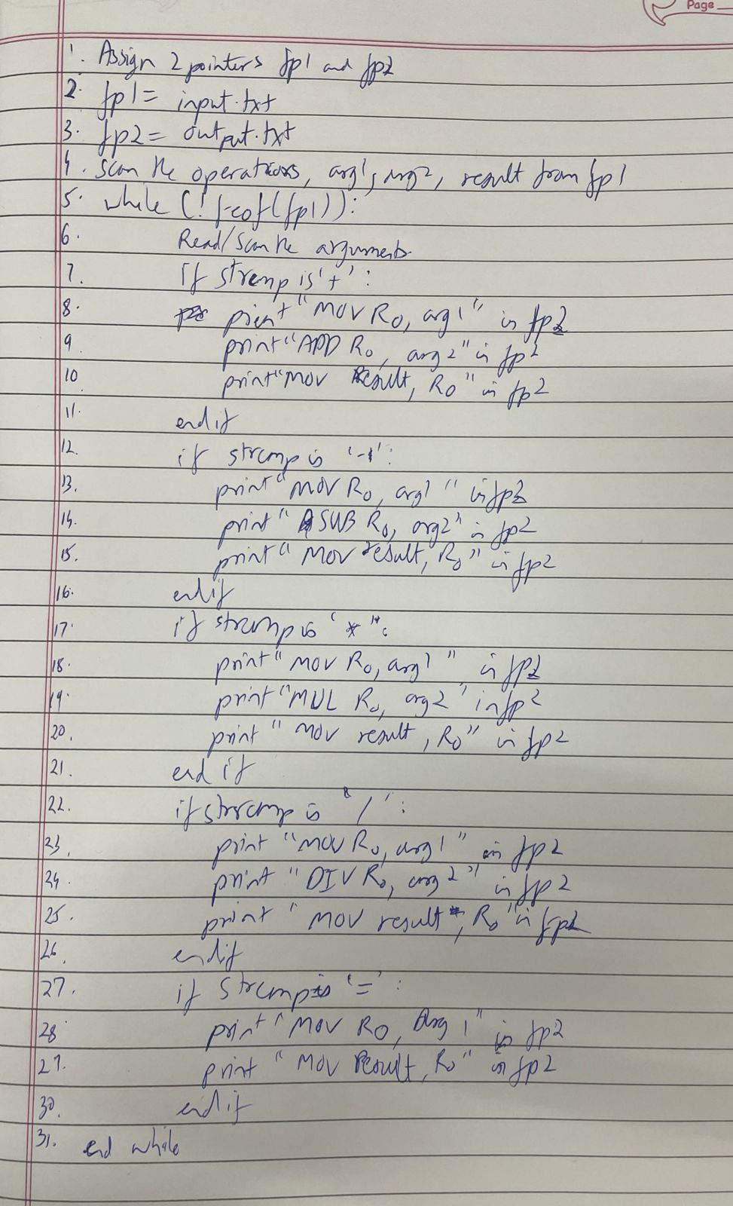

* CODE (C / Java ) – printed code of each

**codegeneration.c -**

#include<stdio.h>

#include<conio.h>

#include<string.h>

char op[2],arg1[5],arg2[5],result[5];

int main()

{

FILE *fp1,*fp2;

fp1=fopen("input.txt","r");

fp2=fopen("output.txt","w");

while(!feof(fp1))

{

fscanf(fp1,"%s%s%s%s",op,arg1,arg2,result);

if(strcmp(op,"+")==0)

{

fprintf(fp2,"\nMOV R0,%s",arg1);

fprintf(fp2,"\nADD R0,%s",arg2);

fprintf(fp2,"\nMOV %s,R0",result);

}

if(strcmp(op,"*")==0)

{

fprintf(fp2,"\nMOV R0,%s",arg1);

fprintf(fp2,"\nMUL R0,%s",arg2);

fprintf(fp2,"\nMOV %s,R0",result);

}

if(strcmp(op,"-")==0)

{

fprintf(fp2,"\nMOV R0,%s",arg1);

fprintf(fp2,"\nSUB R0,%s",arg2);

fprintf(fp2,"\nMOV %s,R0",result);

}

if(strcmp(op,"/")==0)

{

fprintf(fp2,"\nMOV R0,%s",arg1);

fprintf(fp2,"\nDIV R0,%s",arg2);

fprintf(fp2,"\nMOV %s,R0",result);

}

if(strcmp(op,"=")==0)

{

fprintf(fp2,"\nMOV R0,%s",arg1);

fprintf(fp2,"\nMOV %s,R0",result);

}

}

fclose(fp1);

fclose(fp2);

return 0;

}

**input.txt -**

- a b t

- a c u

+ t u v

+ v u d

**OUTPUT:**

**Input :**

3AC for the statement → d : = (a-b) + (a-c) + (a-c)

t = a - b

u = a - c

v = t + u

d = v + u

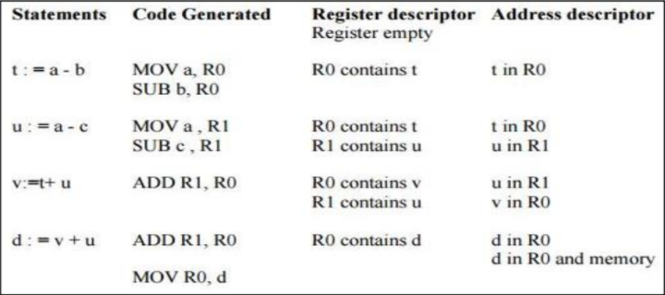

**output.txt -**

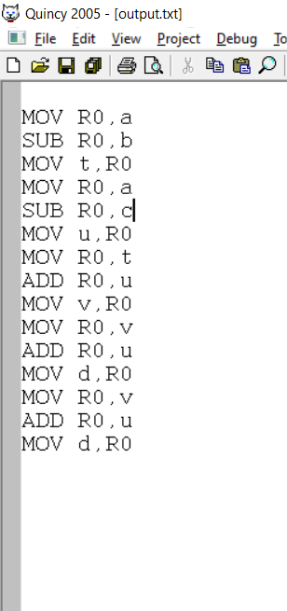

**CONCLUSION:**

The machine code is generated for 3AC using a code generation algorithm.